

**Name of the Assignment :** Digital Clock, Calculator, CV, Radio Button, Check box using GUI

**Course Tittle :** Object oriented programming Lab

**Course Code :** ICT-1204

**Submitted To Submitted By**

Dr. Jesmin Akhter MD Shakil Hossain

Associate Professor Roll - 2023

IIT-JU 1st year 2nd Semester

IIT-JU

Problem 01 : Digital Clock in java.

Login file source code:

import javax.swing.JOptionPane;

public class Login extends javax.swing.JFrame {

public Login() {

initComponents();

}

@SuppressWarnings("unchecked")

// <editor-fold defaultstate="collapsed" desc="Generated Code">

private void txtidActionPerformed(java.awt.event.ActionEvent evt) {

}

private void loginActionPerformed(java.awt.event.ActionEvent evt) {

String id, pas;

id = txtid.getText();

pas = passwrd.getText();

if (id.equals("Shakil") && pas.equals("12345")) {

JOptionPane.showMessageDialog(null, "Successfully");

Login connect = new Login();

connect.setVisible(true);

new Clock().setVisible(true);

} else {

JOptionPane.showMessageDialog(null, "Login Unsuccessfully");

}

}

private void exitActionPerformed(java.awt.event.ActionEvent evt) {

System.exit(0);

}

private void passwrdActionPerformed(java.awt.event.ActionEvent evt) {

}

public static void main(String args[]) {

java.awt.EventQueue.invokeLater(new Runnable() {

public void run() {

new Login().setVisible(true);

}

});

}

// Variables declaration - do not modify

private javax.swing.JTextField display;

private javax.swing.JButton exit;

private javax.swing.JLabel jLabel1;

private javax.swing.JLabel jLabel2;

private javax.swing.JButton login;

private javax.swing.JPasswordField passwrd;

private javax.swing.JTextField txtid;

// End of variables declaration

}

Clock source code:

import java.text.SimpleDateFormat;

import java.util.Calendar;

import java.util.Date;

public class Clock extends javax.swing.JFrame implements Runnable {

int hour, second, minute;

String timestr, yearstr;

public Clock() {

initComponents();

Thread t = new Thread(this);

t.start();

}

@SuppressWarnings("unchecked")

// <editor-fold defaultstate="collapsed" desc="Generated Code">

private void jPanel1AncestorAdded(javax.swing.event.AncestorEvent evt) {

}

public static void main(String args[]) {

java.awt.EventQueue.invokeLater(new Runnable() {

public void run() {

new Clock().setVisible(true);

}

});

}

// Variables declaration - do not modify

private javax.swing.JLabel jLabel1;

private javax.swing.JLabel jLabel2;

private javax.swing.JPanel jPanel1;

private javax.swing.JPanel jPanel2;

private javax.swing.JLabel time;

// End of variables declaration

@Override

public void run() {

while (true) {

try {

Calendar c = Calendar.getInstance();

hour = c.get(Calendar.HOUR_OF_DAY);

if (hour > 12) {

hour -= 12;

}

hour = c.get(Calendar.MINUTE);

hour = c.get(Calendar.SECOND);

SimpleDateFormat sdf = new SimpleDateFormat(" hh : mm : ss a");

Date dat = c.getTime();

timestr = sdf.format(dat);

time.setText(timestr);

} catch (Exception e) {

e.printStackTrace();

}

}

}

}

Output :

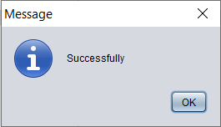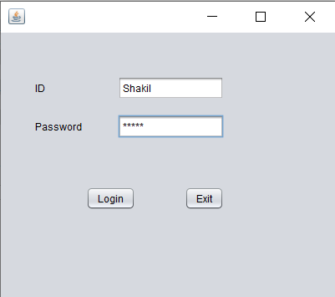

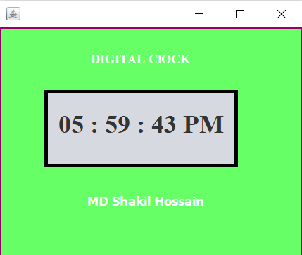

Problem 02 : Calculator in java.

Login file source code:

import javax.swing.JOptionPane;

public class Login extends javax.swing.JFrame {

public Login() {

initComponents();

}

@SuppressWarnings("unchecked")

// <editor-fold defaultstate="collapsed" desc="Generated Code">

private void txtidActionPerformed(java.awt.event.ActionEvent evt) {

}

private void loginActionPerformed(java.awt.event.ActionEvent evt) {

String id, pas;

id = txtid.getText();

pas = passwrd.getText();

if (id.equals("Shakil") && pas.equals("12345")) {

JOptionPane.showMessageDialog(null, "Successfully");

Login connect = new Login();

connect.setVisible(true);

new Calculator().setVisible(true);

} else {

JOptionPane.showMessageDialog(null, "Login Unsuccessfully");

}

}

private void exitActionPerformed(java.awt.event.ActionEvent evt) {

System.exit(0);

}

private void passwrdActionPerformed(java.awt.event.ActionEvent evt) {

}

public static void main(String args[]) {

java.awt.EventQueue.invokeLater(new Runnable() {

public void run() {

new Login().setVisible(true);

}

});

}

// Variables declaration - do not modify

private javax.swing.JTextField display;

private javax.swing.JButton exit;

private javax.swing.JLabel jLabel1;

private javax.swing.JLabel jLabel2;

private javax.swing.JButton login;

private javax.swing.JPasswordField passwrd;

private javax.swing.JTextField txtid;

// End of variables declaration

}

Calculator source code:

import static jdk.nashorn.internal.objects.NativeString.substr;

public class Calculator extends javax.swing.JFrame {

double first_num, second_num, result;

String operations;

public Calculator() {

initComponents();

}

@SuppressWarnings("unchecked")

// <editor-fold defaultstate="collapsed" desc="Generated Code">

private void pmActionPerformed(java.awt.event.ActionEvent evt) {

Double n = Double.parseDouble(String.valueOf(dis.getText()));

n = n * (-1);

dis.setText(String.valueOf(n));

}

private void threeActionPerformed(java.awt.event.ActionEvent evt) {

String n = dis.getText() + three.getText();

dis.setText(n);

}

private void oneActionPerformed(java.awt.event.ActionEvent evt) {

String n = dis.getText() + one.getText();

dis.setText(n);

}

private void twoActionPerformed(java.awt.event.ActionEvent evt) {

String n = dis.getText() + two.getText();

dis.setText(n);

}

private void fourActionPerformed(java.awt.event.ActionEvent evt) {

String n = dis.getText() + four.getText();

dis.setText(n);

}

private void fiveActionPerformed(java.awt.event.ActionEvent evt) {

String n = dis.getText() + five.getText();

dis.setText(n);

}

private void sixActionPerformed(java.awt.event.ActionEvent evt) {

String n = dis.getText() + six.getText();

dis.setText(n);

}

private void sevenActionPerformed(java.awt.event.ActionEvent evt) {

String n = dis.getText() + seven.getText();

dis.setText(n);

}

private void eightActionPerformed(java.awt.event.ActionEvent evt) {

String n = dis.getText() + eight.getText();

dis.setText(n);

}

private void nineActionPerformed(java.awt.event.ActionEvent evt) {

String n = dis.getText() + nine.getText();

dis.setText(n);

}

private void zeroActionPerformed(java.awt.event.ActionEvent evt) {

String n = dis.getText() + zero.getText();

dis.setText(n);

}

private void cActionPerformed(java.awt.event.ActionEvent evt) {

dis.setText("");

}

private void plusActionPerformed(java.awt.event.ActionEvent evt) {

first_num = Double.parseDouble(dis.getText());

dis.setText("");

operations = "+";

}

private void minusActionPerformed(java.awt.event.ActionEvent evt) {

first_num = Double.parseDouble(dis.getText());

dis.setText("");

operations = "-";

}

private void vagActionPerformed(java.awt.event.ActionEvent evt) {

first_num = Double.parseDouble(dis.getText());

dis.setText("");

operations = "/";

}

private void gunActionPerformed(java.awt.event.ActionEvent evt) {

first_num = Double.parseDouble(dis.getText());

dis.setText("");

operations = "*";

}

private void somanActionPerformed(java.awt.event.ActionEvent evt) {

String ans;

second_num = Double.parseDouble(dis.getText());

if (operations == "+") {

result = first_num + second_num;

ans = String.format("%.0f", result);

dis.setText(ans);

} else if (operations == "-") {

result = first_num - second_num;

ans = String.format("%.0f", result);

dis.setText(ans);

} else if (operations == "*") {

result = first_num * second_num;

ans = String.format("%.0f", result);

dis.setText(ans);

} else if (operations == "/") {

result = first_num / second_num;

ans = String.format("%.0f", result);

dis.setText(ans);

} else if (operations == "%") {

result = first_num % second_num;

ans = String.format("%.0f", result);

dis.setText(ans);

}

}

private void pointActionPerformed(java.awt.event.ActionEvent evt) {

String n = dis.getText() + point.getText();

dis.setText(n);

}

public static void main(String args[]) {

java.awt.EventQueue.invokeLater(new Runnable() {

public void run() {

new Calculator().setVisible(true);

}

});

}

private javax.swing.JButton c;

private javax.swing.JTextField dis;

private javax.swing.JButton eight;

private javax.swing.JButton five;

private javax.swing.JButton four;

private javax.swing.JButton gun;

private javax.swing.JButton minus;

private javax.swing.JButton nine;

private javax.swing.JButton one;

private javax.swing.JButton plus;

private javax.swing.JButton pm;

private javax.swing.JButton point;

private javax.swing.JButton seven;

private javax.swing.JButton six;

private javax.swing.JButton soman;

private javax.swing.JButton three;

private javax.swing.JButton two;

private javax.swing.JButton vag;

private javax.swing.JButton zero;

}

Output:



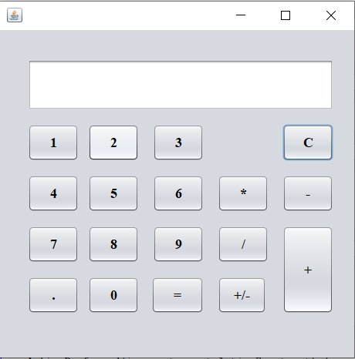

Problem 03 : Curriculum Vita in java.

Login file source code:

import javax.swing.JOptionPane;

public class Login extends javax.swing.JFrame {

public Login() {

initComponents();

}

@SuppressWarnings("unchecked")

// <editor-fold defaultstate="collapsed" desc="Generated Code">

private void txtidActionPerformed(java.awt.event.ActionEvent evt) {

}

private void loginActionPerformed(java.awt.event.ActionEvent evt) {

String id, pas;

id = txtid.getText();

pas = passwrd.getText();

if (id.equals("Shakil") && pas.equals("12345")) {

JOptionPane.showMessageDialog(null, "Successfully");

Login connect = new Login();

connect.setVisible(true);

//new Clock().setVisible(true);

new Calculator().setVisible(true);

//new CV().setVisible(true);

} else {

JOptionPane.showMessageDialog(null, "Login Unsuccessfully");

}

}

private void exitActionPerformed(java.awt.event.ActionEvent evt) {

System.exit(0);

}

private void passwrdActionPerformed(java.awt.event.ActionEvent evt) {

}

public static void main(String args[]) {

java.awt.EventQueue.invokeLater(new Runnable() {

public void run() {

new Login().setVisible(true);

}

});

}

// Variables declaration - do not modify

private javax.swing.JTextField display;

private javax.swing.JButton exit;

private javax.swing.JLabel jLabel1;

private javax.swing.JLabel jLabel2;

private javax.swing.JButton login;

private javax.swing.JPasswordField passwrd;

private javax.swing.JTextField txtid;

// End of variables declaration

}

CV source code:

public class CV extends javax.swing.JFrame {

public CV() {

initComponents();

}

@SuppressWarnings("unchecked")

// <editor-fold defaultstate="collapsed" desc="Generated Code">

private void jButton2ActionPerformed(java.awt.event.ActionEvent evt) {

}

private void sActionPerformed(java.awt.event.ActionEvent evt) {

String a = name.getText();

String b = name.getText();

String c = mname.getText();

String d = padd.getText();

String e = phone.getText();

String f = email.getText();

String g = religion.getText();

String h = nationality.getText();

new Information(a, b, c, d, e, f, g, h).setVisible(true);

}

private void mnameActionPerformed(java.awt.event.ActionEvent evt) {

}

public static void main(String args[]) {

java.awt.EventQueue.invokeLater(new Runnable() {

@Override

public void run() {

new CV().setVisible(true);

}

});

}

// Variables declaration - do not modify

private javax.swing.JTextField email;

private javax.swing.Box.Filler filler1;

private javax.swing.JTextField fname;

private javax.swing.JButton jButton2;

private javax.swing.JLabel jLabel1;

private javax.swing.JLabel jLabel10;

private javax.swing.JLabel jLabel11;

private javax.swing.JLabel jLabel2;

private javax.swing.JLabel jLabel3;

private javax.swing.JLabel jLabel4;

private javax.swing.JLabel jLabel5;

private javax.swing.JLabel jLabel6;

private javax.swing.JLabel jLabel7;

private javax.swing.JLabel jLabel8;

private javax.swing.JTextField mname;

private javax.swing.JTextField name;

private javax.swing.JTextField nationality;

private javax.swing.JTextField padd;

private javax.swing.JTextField phone;

private javax.swing.JTextField religion;

private javax.swing.JButton s;

}

CV Information show source code:

public class Information extends javax.swing.JFrame {

public Information(String a, String b, String c, String d, String e, String f, String g, String h) {

initComponents();

name.setText(a);

fname.setText(b);

mname.setText(c);

padd.setText(d);

phone.setText(e);

email.setText(f);

religion.setText(g);

nationality.setText(h);

}

@SuppressWarnings("unchecked")

// <editor-fold defaultstate="collapsed" desc="Generated Code">

public static void main(String args[]) {

java.awt.EventQueue.invokeLater(new Runnable() {

public void run() {

new CV().setVisible(true);

}

});

}

// Variables declaration - do not modify

private javax.swing.JLabel e;

private javax.swing.JLabel e1;

private javax.swing.JLabel email;

private javax.swing.JLabel f;

private javax.swing.JLabel fname;

private javax.swing.JLabel g;

private javax.swing.JLabel h;

private javax.swing.JLabel jLabel1;

private javax.swing.JLabel jLabel10;

private javax.swing.JLabel jLabel11;

private javax.swing.JLabel jLabel2;

private javax.swing.JLabel jLabel3;

private javax.swing.JLabel jLabel4;

private javax.swing.JLabel jLabel5;

private javax.swing.JLabel jLabel6;

private javax.swing.JLabel jLabel7;

private javax.swing.JLabel jLabel8;

private javax.swing.JLabel jLabel9;

private javax.swing.JLabel mname;

private javax.swing.JLabel mname4;

private javax.swing.JLabel name;

private javax.swing.JLabel nationality;

private javax.swing.JLabel padd;

private javax.swing.JLabel phone;

private javax.swing.JLabel religion;

// End of variables declaration

}

Output:



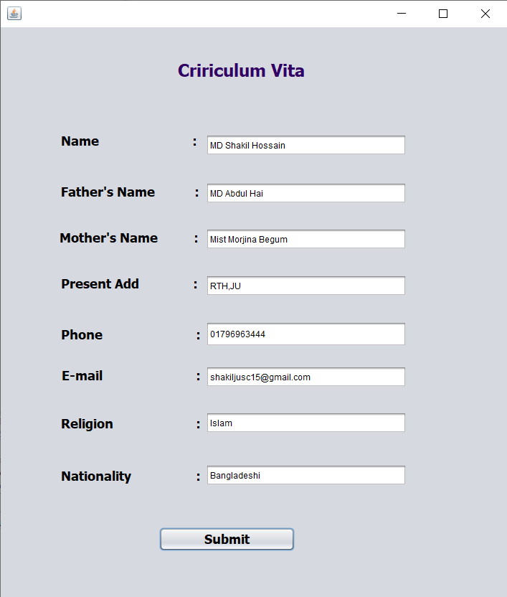

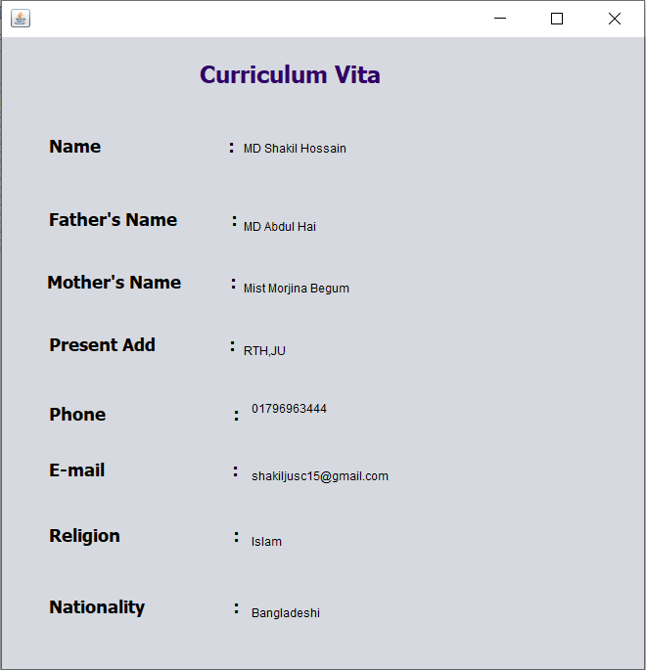

Problem 04: Radio Button

Radio Button source code:

import javax.swing.JOptionPane;

public class RadioButton extends javax.swing.JFrame {

public RadioButton() {

initComponents();

}

@SuppressWarnings("unchecked")

private void jRadioButton1ActionPerformed(java.awt.event.ActionEvent evt) {

}

private void jButton1ActionPerformed(java.awt.event.ActionEvent evt) {

String str = "I like ";

if (jRadioButton1.isSelected())

{

str += "Apple ";

}

if (jRadioButton2.isSelected())

{

str += "Banana ";

}

if (jRadioButton3.isSelected())

{

str += "Orange ";

}

if (jRadioButton4.isSelected())

{

str += "Mango ";

}

JOptionPane.showMessageDialog(this, str);

}

public static void main(String args[]) {

java.awt.EventQueue.invokeLater(new Runnable() {

public void run() {

new RadioButton().setVisible(true);

}

});

}

// Variables declaration - do not modify

private javax.swing.JButton jButton1;

private javax.swing.JLabel jLabel1;

private javax.swing.JRadioButton jRadioButton1;

private javax.swing.JRadioButton jRadioButton2;

private javax.swing.JRadioButton jRadioButton3;

private javax.swing.JRadioButton jRadioButton4;

// End of variables declaration

}

Output:

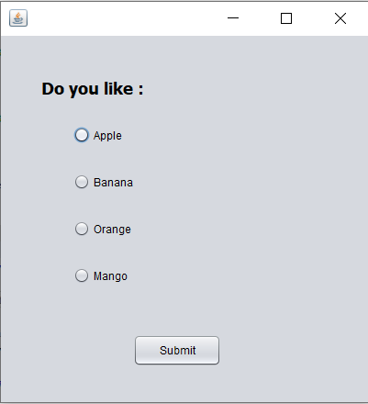

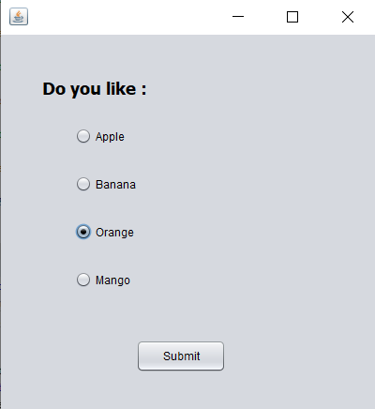

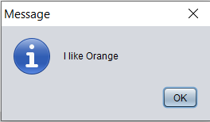

Problem 05 : Check Box.

Check Box source code:

import javax.swing.JOptionPane;

public class CheckBox extends javax.swing.JFrame {

public CheckBox() {

initComponents();

}

@SuppressWarnings("unchecked")

private void jButton1ActionPerformed(java.awt.event.ActionEvent evt) {

String str = null;

if (jCheckBox1.isSelected())

{

JOptionPane.showMessageDialog(this,"YES! I like Mango.");

}

if (jCheckBox2.isSelected())

{

JOptionPane.showMessageDialog(this,"NO! I don't like mango.");

}

}

private void jCheckBox1ActionPerformed(java.awt.event.ActionEvent evt) {

if (jCheckBox1.isSelected())

{

jCheckBox2.setSelected(false);

}

}

private void jCheckBox2ActionPerformed(java.awt.event.ActionEvent evt) {

if (jCheckBox2.isSelected())

{

jCheckBox1.setSelected(false);

}

}

public static void main(String args[]) {

java.awt.EventQueue.invokeLater(new Runnable() {

public void run() {

new CheckBox().setVisible(true);

}

});

}

// Variables declaration - do not modify

private javax.swing.JButton jButton1;

private javax.swing.JCheckBox jCheckBox1;

private javax.swing.JCheckBox jCheckBox2;

private javax.swing.JLabel jLabel1;

// End of variables declaration

}

Output:

